**PROJECT DOCUMENTATION**

**Topic: “THE TRAGEDY OF FLIGHT: A COMPREHENSIVE CRASH ANALYSIS”**

**1. INTRODUCTION:**

***1.1 OVERVIEW:***

An airplane crash analysis is to investigate the accident and identify the events and conditions that caused the crash. The goal of an airplane crash analysis is to identify the factors that contributed to the accident, with the ultimate goal of improving safety and preventing future accidents.

***1.2 PURPOSE:***

The crash of different countries are traced out. We can effectively discover the hazards that led to the accident and to prevent future accidents.

**2. PROBLEM DEFINITION AND DESIGN THINKING:**

***2.1 EMPATHY MAP:***

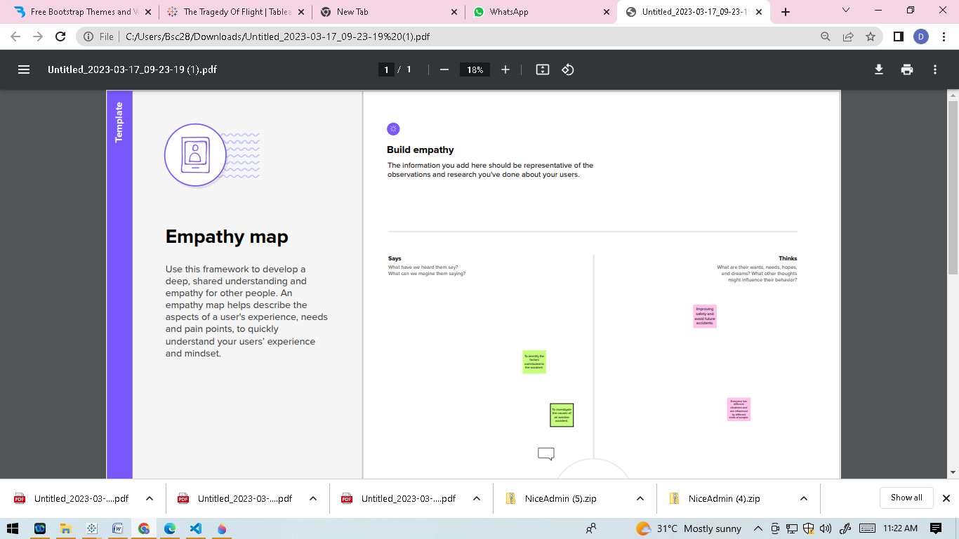

***2.2 IDEATION AND BRAINSTORMING MAP:***

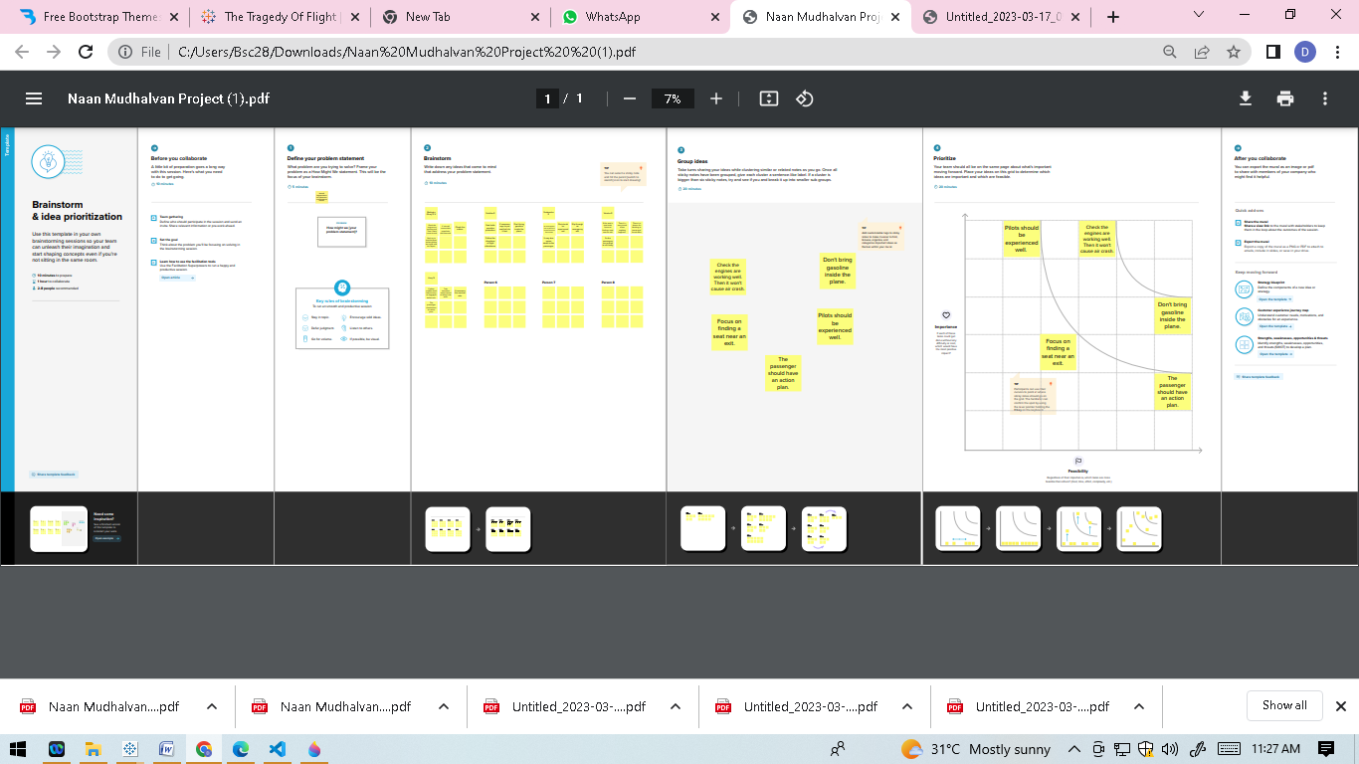

**3. RESULT:**

***1. TABLEAU PUBLIC:***

Created a tableau public account and imported the dashboard and story there.

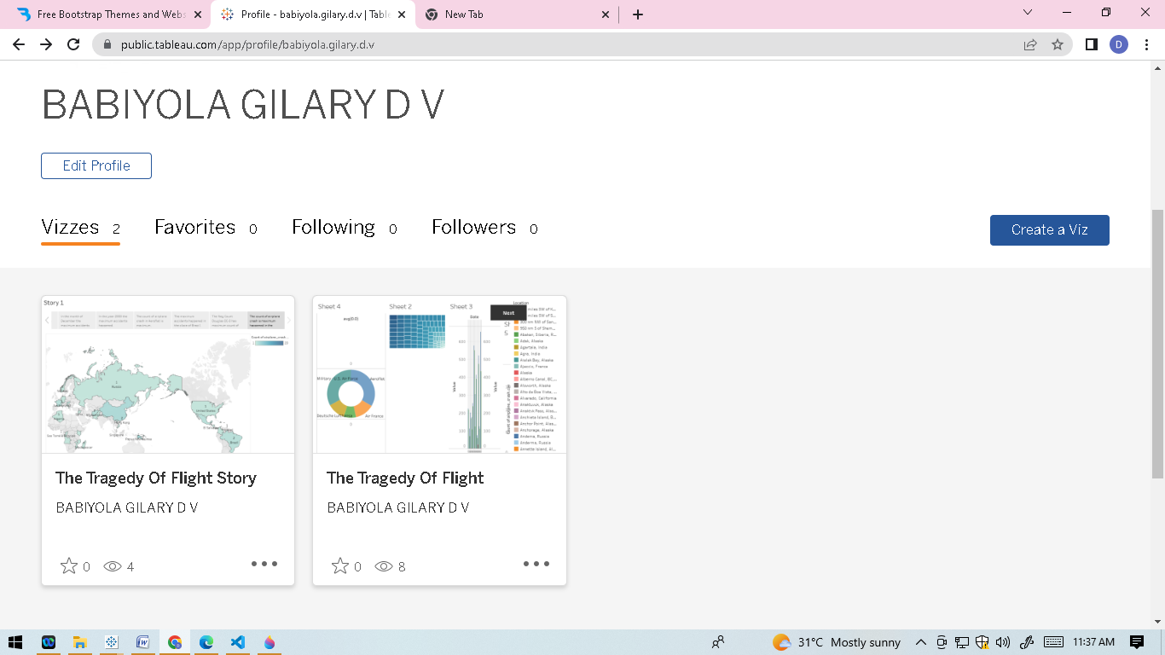

***2. DASHBOARD:***

Created the dashboard by using the dataset.

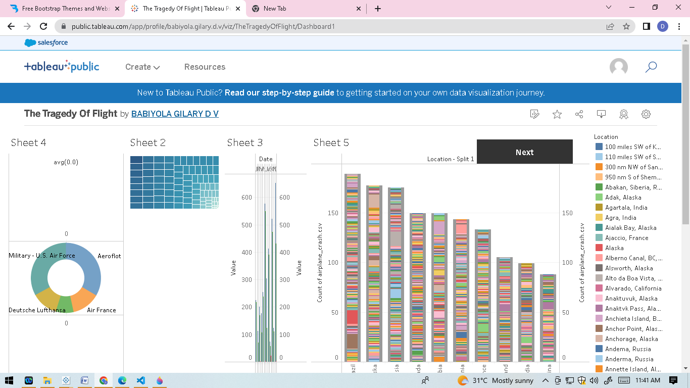

***3. STORY:***

Created the story from the given dataset.

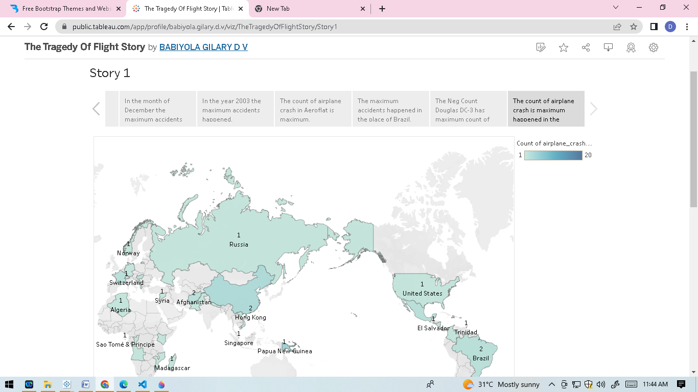

***4. WEB APPLICATION:***

Used certain applications to establish a dashboard and story to embed.

**4. ADVANTAGES AND DISADVANTAGES:**

The best advantage of airplane is we can go anywhere fast. We can around the world in a matter of hours. Flying is one of the best experience. While comparing to the other transportations it is very pleasant.Flying helps us to relax. It is one of the safe transportation.Travelling by plane is chance to see the new places.

The emission of fuels from the airpane causes climate change. Airplane has strong warming effects. The dying in a plane crash is about million. The aircraft weight, atmospheric conditions affect the aircraft performance.

**6. APPLICATION:**

To prevent the future accidents, investigate the aircraft accidents, and make the safety recommendations.

**7. CONCLUSION:**

The investigators can evaluate the survivability of the airplane crash.

**8. FUTURE SCOPE:**

Reduce the aircraft accidents, improve the pilot’s experiences how to handle the situation.

**9. APPENDIX:**

<!DOCTYPE html>

<html lang="en">

<head>

  <meta charset="utf-8">

  <meta content="width=device-width, initial-scale=1.0" name="viewport">

  <title>Arsha Bootstrap Template - Index</title>

  <meta content="" name="description">

  <meta content="" name="keywords">

  <!-- Favicons -->

  <link href="assets/img/favicon.png" rel="icon">

  <link href="assets/img/apple-touch-icon.png" rel="apple-touch-icon">

  <!-- Google Fonts -->

  <link href="https://fonts.googleapis.com/css?family=Open+Sans:300,300i,400,400i,600,600i,700,700i|Jost:300,300i,400,400i,500,500i,600,600i,700,700i|Poppins:300,300i,400,400i,500,500i,600,600i,700,700i" rel="stylesheet">

  <!-- Vendor CSS Files -->

  <link href="assets/vendor/aos/aos.css" rel="stylesheet">

  <link href="assets/vendor/bootstrap/css/bootstrap.min.css" rel="stylesheet">

  <link href="assets/vendor/bootstrap-icons/bootstrap-icons.css" rel="stylesheet">

  <link href="assets/vendor/boxicons/css/boxicons.min.css" rel="stylesheet">

  <link href="assets/vendor/glightbox/css/glightbox.min.css" rel="stylesheet">

  <link href="assets/vendor/remixicon/remixicon.css" rel="stylesheet">

  <link href="assets/vendor/swiper/swiper-bundle.min.css" rel="stylesheet">

  <!-- Template Main CSS File -->

  <link href="assets/css/style.css" rel="stylesheet">

  <!-- =======================================================

  * Template Name: Arsha

  * Updated: Mar 10 2023 with Bootstrap v5.2.3

  * Template URL: https://bootstrapmade.com/arsha-free-bootstrap-html-template-corporate/

  * Author: BootstrapMade.com

  * License: https://bootstrapmade.com/license/

  ======================================================== -->

</head>

<body>

  <!-- ======= Header ======= -->

  <header id="header" class="fixed-top ">

    <div class="container d-flex align-items-center">

      <h1 class="logo me-auto"><a href="index.html">The Tragedy of Flight</a></h1>

      <!-- Uncomment below if you prefer to use an image logo -->

      <!-- <a href="index.html" class="logo me-auto"><img src="assets/img/logo.png" alt="" class="img-fluid"></a>-->

      <nav id="navbar" class="navbar">

        <ul>

          <li><a class="nav-link scrollto active" href="#hero">Home</a></li>

          <li><a class="nav-link scrollto" href="#services">Dashboard</a></li>

          <li><a class="nav-link scrollto" href="#services hero">Story</a></li>

    </div>

  </header><!-- End Header -->

  <!-- ======= Hero Section ======= -->

  <section id="hero" class="d-flex align-items-center">

    <div class="container">

      <div class="row">

          <h1>A Comprehensive Crash Analysis</h1>

        </div>

        <div class="col-lg-6 order-1 order-lg-2 hero-img" data-aos="zoom-in" data-aos-delay="200">

          <img src="assets/img/hero-img.png" class="img-fluid animated" alt="">

        </div>

      </div>

    </div>

  </section><!-- End Hero -->

  <main id="main">

<!-- ======= Dashboard Section ======= -->

<section id="services" class="story section-bg">

  <div class="container" data-aos="fade-up">

    <div class="section-title">

      <h2>dashboard</h2>

      <div class='tableauPlaceholder' id='viz1681379997923' style='position: relative'><noscript><a href='#'><img alt='Dashboard 1 ' src='https:&#47;&#47;public.tableau.com&#47;static&#47;images&#47;Th&#47;TheTragedyOfFlight&#47;Dashboard1&#47;1_rss.png' style='border: none' /></a></noscript><object class='tableauViz'  style='display:none;'><param name='host_url' value='https%3A%2F%2Fpublic.tableau.com%2F' /> <param name='embed_code_version' value='3' /> <param name='site_root' value='' /><param name='name' value='TheTragedyOfFlight&#47;Dashboard1' /><param name='tabs' value='no' /><param name='toolbar' value='yes' /><param name='static_image' value='https:&#47;&#47;public.tableau.com&#47;static&#47;images&#47;Th&#47;TheTragedyOfFlight&#47;Dashboard1&#47;1.png' /> <param name='animate_transition' value='yes' /><param name='display_static_image' value='yes' /><param name='display_spinner' value='yes' /><param name='display_overlay' value='yes' /><param name='display_count' value='yes' /><param name='language' value='en-US' /></object></div>                <script type='text/javascript'>                    var divElement = document.getElementById('viz1681379997923');                    var vizElement = divElement.getElementsByTagName('object')[0];                    if ( divElement.offsetWidth > 800 ) { vizElement.style.width='100%';vizElement.style.height=(divElement.offsetWidth*0.75)+'px';} else if ( divElement.offsetWidth > 500 ) { vizElement.style.width='100%';vizElement.style.height=(divElement.offsetWidth*0.75)+'px';} else { vizElement.style.width='100%';vizElement.style.height='1327px';}                     var scriptElement = document.createElement('script');                    scriptElement.src = 'https://public.tableau.com/javascripts/api/viz_v1.js';                    vizElement.parentNode.insertBefore(scriptElement, vizElement);                </script>

        </div>

      </div>

    </div>

</section><!-- End Story Section -->

<!-- ======= Dashboard Section ======= -->

<section id="services hero" class="story section-bg">

  <div class="container" data-aos="fade-up">

    <div class="section-title">

      <h2>story</h2>

      <div class='tableauPlaceholder' id='viz1681381080771' style='position: relative'><noscript><a href='#'><img alt='Story 1 ' src='https:&#47;&#47;public.tableau.com&#47;static&#47;images&#47;Th&#47;TheTragedyOfFlightStory&#47;Story1&#47;1_rss.png' style='border: none' /></a></noscript><object class='tableauViz'  style='display:none;'><param name='host_url' value='https%3A%2F%2Fpublic.tableau.com%2F' /> <param name='embed_code_version' value='3' /> <param name='site_root' value='' /><param name='name' value='TheTragedyOfFlightStory&#47;Story1' /><param name='tabs' value='no' /><param name='toolbar' value='yes' /><param name='static_image' value='https:&#47;&#47;public.tableau.com&#47;static&#47;images&#47;Th&#47;TheTragedyOfFlightStory&#47;Story1&#47;1.png' /> <param name='animate_transition' value='yes' /><param name='display_static_image' value='yes' /><param name='display_spinner' value='yes' /><param name='display_overlay' value='yes' /><param name='display_count' value='yes' /><param name='language' value='en-US' /></object></div>                <script type='text/javascript'>                    var divElement = document.getElementById('viz1681381080771');                    var vizElement = divElement.getElementsByTagName('object')[0];                    vizElement.style.width='1016px';vizElement.style.height='991px';                    var scriptElement = document.createElement('script');                    scriptElement.src = 'https://public.tableau.com/javascripts/api/viz_v1.js';                    vizElement.parentNode.insertBefore(scriptElement, vizElement);                </script>

        </div>

      </div>

    </div>

  </div>

</section><!-- End Story Section -->

  <!-- Vendor JS Files -->

  <script src="assets/vendor/aos/aos.js"></script>

  <script src="assets/vendor/bootstrap/js/bootstrap.bundle.min.js"></script>

  <script src="assets/vendor/glightbox/js/glightbox.min.js"></script>

  <script src="assets/vendor/isotope-layout/isotope.pkgd.min.js"></script>

  <script src="assets/vendor/swiper/swiper-bundle.min.js"></script>

  <script src="assets/vendor/waypoints/noframework.waypoints.js"></script>

  <script src="assets/vendor/php-email-form/validate.js"></script>

  <!-- Template Main JS File -->

  <script src="assets/js/main.js"></script>

</body>

</html>